Celebrate Aurora
Meeting Agenda
Aurora Community Center
April 7th, 2022 at 6pm

Topic | Discussion | Decision | Responsible Person
Call Meeting to Order
Attendance

Secretary’s Report
Approve Minutes | - March 3rd, 2022
Correspondence
Treasurer’s Report | 2022 Financial Update: $50,951  - Overhead: $27,754  - Patriotic: $11,635  - Pumpkin Fest: $8,832  - Cliffs: $2,182  - Memorial: $548
Old Business | - Grand Marshal- Butch Ceglar
New Business
Marketing | - Event Schedule: Revise 2021 Below
Patriotic Days | - Brian Carlson: Entertainment  - Options: More info below  - The Simple Guys Roaming Band  - Iron Will  - Vocal Perspective  - Budget  - Inflatables  - Lefty’s  - Cliff’s Grant  - Patriotic Day button  - Live Entertainment  - Float-Mesabi Sign- Al Hodnik  - Sawdust Pile
Vendors | - Food Vendors  - Celebrate Aurora Booth:Co-Chair Al H. & ?  - Mesabi Sign-Al Hodnik  - Menu Items  - Window treatment  - other  - Vendors  - Outdoor vs Indoor
Parade | - Patriotic Parade  - Kiddie Parade: AFD  - Kids Races to follow (AFD)  - CA prizes and judges  - 148th Flyover  - Sullivan Candy (2021 Cost: $499)  - Parade Route- See below  - Eveleth Clown Band
Fireworks | - Town of White Request: Approved  - J&M Display (formerly known as Pyrotechnic Display)  - $10,000: Now 12k
Website | - Meeting Recap for website updates  - Ideas for website improvement
Pumpkin Fest | October 1st, 2022  - Additional Vendor Locations  - Discuss local business involvement  - Vending fee  - Food Trucks
Fundraising | - Community Spirit Raffle  - 26 winners-Ongoing Project
Other Business | - City Council Request: April  - 2nd City request  - Parade Route  - Apply for Grants  - Essentia, Etc  - Volunteer Coordinator  - 3rd of July
Next Meeting  Adjourn | 6:00pm on April 7th  Venue: TBD

PROPOSED PARADE ROUTE 2022:
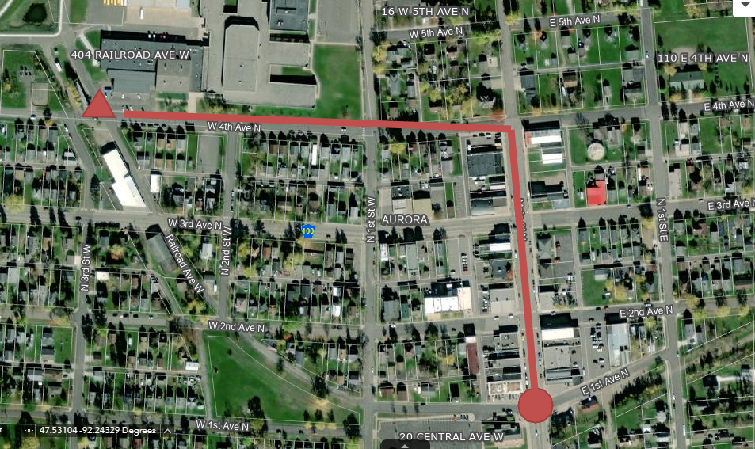
2021 Event Schedule

Aurora Patriotic Days:

Friday, July 2nd
- Quilt Show & Crafts at The Hive Coffee and Bakehouse (10am-4pm)
Up North Quilt Guild 14th Annual quilt and craft show. Viewer’s choice. Finished items for sale. Quilt drawings at 3pm on July 3rd.
Veterans bring your ID and register for a Quilt of Valor.
New members welcome!
- Northern Lights Music Festival (7pm)
Veda Zupancich Auditorium
Opening Night Chamber Concert featuring renowned performing faculty. After the concert, meet the artists.

Saturday, July 3rd
- Quilt Show & Crafts at The Hive Coffee and Bakehouse (10am-4pm)
Quilt Drawings at 3pm. Viewer’s choice. Finished items for sale. Veterans bring your ID and register for a Quilt of Valor. New members welcome!
- Food vendors open throughout the day as they choose
- Medallion Hunt (Noon-Until found)

- Sawdust Pile (1pm)
Location to be determined. Five age groups with prizes sponsored by The Red Can Trailer.
- Aurora Public Library Mural Dedication and Make and Take Kids Crafts (2pm)
Time: 2pm-4pm
Make and take children's craft and ice cream social (while supplies last).
Mural dedication for the Aurora Public Library.
- ALS Bean Bag Tournament (2pm)
Tournament starts at 2 pm
Setup and sign in at 1 p.m. on Main Street
by Aurora American Legion. All proceeds benefit the ALS Association of MN/ND/SD chapter.
- Eino & Terry Koivisto Car Show (2pm)
Time: 2:00pm - 5:30pm. Public judging 4:00pm.
3rd Annual Eino & Terry Koivisoto Vintage Car Show on Main Street Aurora!
All vintage age cars are eligible for parade entry. Prizes awarded.
Call Nancy at (218)404-4664.
- Hybrid Kiddie & Patriotic Parade (5:30pm)
Time: 5:30pm
Grand Marshal is Tom Gillach!
Sign in near ME3C (formerly Plegmann’s Floral) with lineup and registration beginning at 4:15pm along 3rd Avenue North. Prizes awarded during lineup with awards. All decisions made by parade judges are final. You must be registered in a specific category in order to win. Classic cars are encouraged to lead the parade.
- Kids Races (Immediately following the parade)
Located on Main Street by the Aurora American Legion. Coordinated by the Aurora Fire Department.
- Pyrotechnic Firework Display from Red Top (10pm)

Sunday, July 4th
- Northern Lights Music Festival (4pm)
Veda Zupancich Auditorium
Festive 4th! Concert with the Northern Lights Music Festival Orchestra, Gavriel Heine conducting. Featuring opera arias performed by stars of the NLMF Opera!

****All events are scheduled to change. Please note, most programs are weather contingent. If a light drizzle, most events will continue. If there is a downpour, we will regrettably need to cancel events.

2022 Entertainment:

The Simple Guys- Roaming act-$650 for 3 sets of 45 minutes – do sing-a-longs, kids tunes, interactive music for young at heart. Move from area to area to share their talent with those attending.
Iron Will- $750/day. Covered by arts and culture grants just as the other offerings are.
Vocal Perspective: offering kids music; 3 sets of 45 minutes -$750.https://youtube.com/channel/UCUBrytl7D4N4aRi_cuXlHzQ

